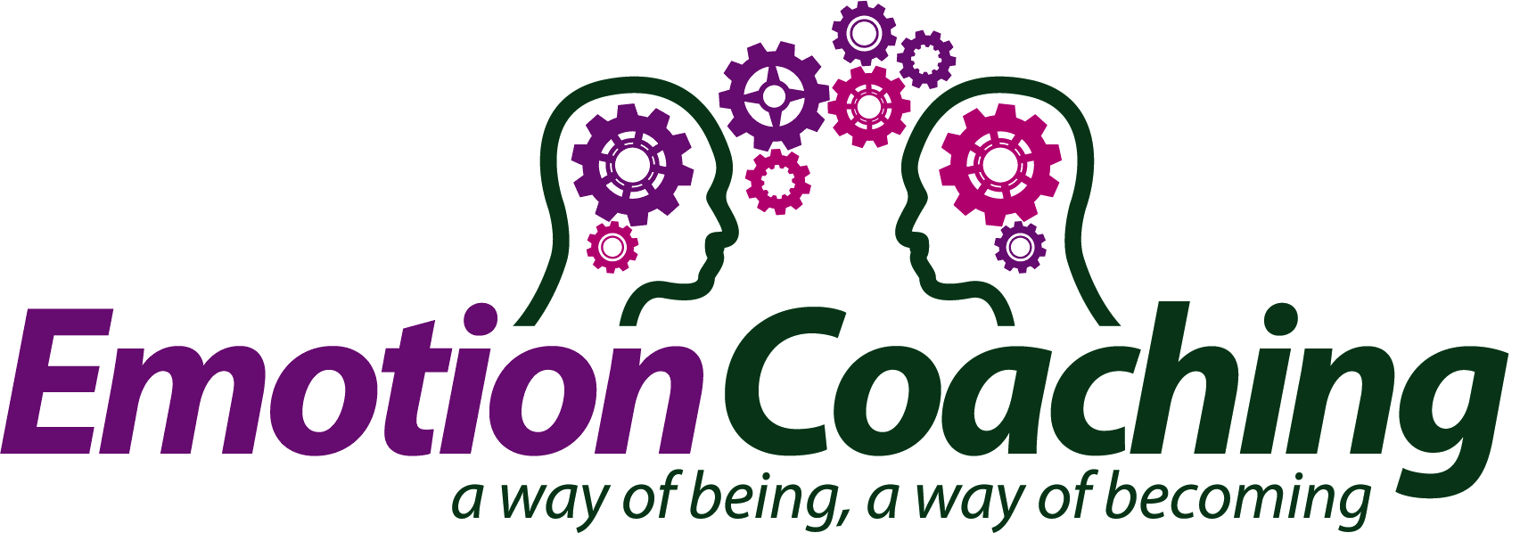

ECUK Code of Conduct declaration
This document is intended to evidence to readers and followers trust and confidence in the principles that structure Emotion Coaching UK (ECUK) and guides our not-for-profit organisation in business and work with other like-minded organisations.

We are committed to actively promoting and supporting Emotion Coaching practice that is sensitive to and respectful of cultural contexts; is inclusive and reflects the needs of children and adults and promotes shared, local expertise.

ECUK offers support to recognised organisations that are independent of ECUK however they share our origins, values and interests, and are promoting EC practice around the world. These alliances do not imply joint venture, partnership, or principal-agent relationship. Rather, that we share a mutual respect of organisational autonomy, and encourage efforts to promote Emotion Coaching practice to reflect and satisfy the specific needs of country and people.

Informed by the Information Commissioner’s Office (IOC) Personal Information Promise:

We at Emotion Coaching UK promise to:
- value personal information entrusted to us and make sure we respect that trust;
- uphold the law when it comes to handling personal information, and adopt good practice standards;
- consider and address the privacy risks first when we are planning to use or hold personal information in new ways, such as when introducing new systems;
- be open with individuals about how we use their information and who we give it to;
- make it easy for individuals to access and correct their personal information;
- keep personal information to the minimum necessary and delete when we no longer needed;
- have effective safeguards in place to make sure personal information is kept securely;
- provide training to staff who handle personal information and treat it as a disciplinary matter if they misuse or don’t look after personal information properly;
- put appropriate financial and human resources into looking after personal information to make sure we can live up to our promises; and
- regularly check that we are living up to our promises on how we are doing.

